D-Separation Examples

Consider the following Bayes Net graph:

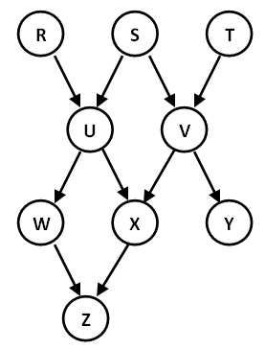
Determine for each statement below, whether or not it is guaranteed to be true, based on D-Separation.
If not guaranteed, give at least one active path that prevents the guarantee.

1. R ⊥ S
Guaranteed

2. U ⊥ T | V
Not Guaranteed (USVT)

3. R ⊥ T | U, V
Not Guaranteed (RUSVT)

4. R ⊥ T | W
Guaranteed

5. R ⊥ T | W, V
Not Guaranteed (RUWZXVT)

6. X ⊥ T | U, V
Not Guaranteed (XVT)

7. S ⊥ T | Z
Not Guaranteed (SVT)

